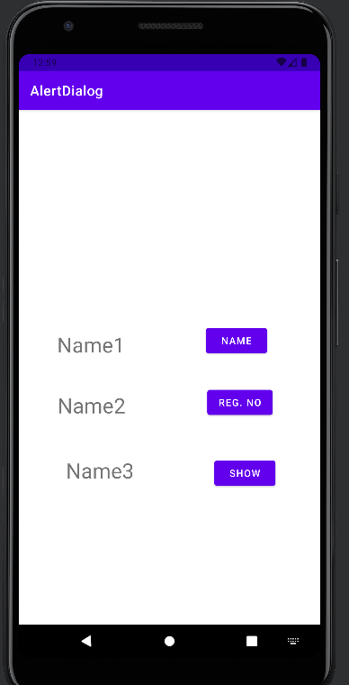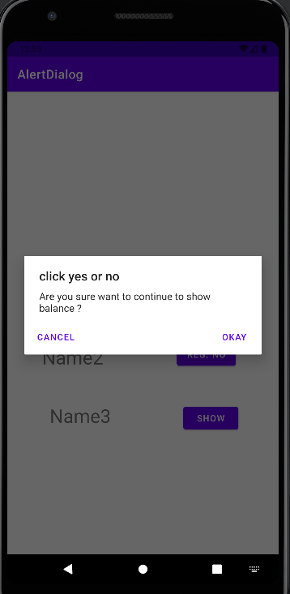

Kotlin code

package com.example.alertdialog  
  
import android.annotation.SuppressLint  
import android.os.Bundle  
import android.widget.Button  
import android.widget.TextView  
import android.widget.Toast  
import androidx.appcompat.app.AlertDialog  
import androidx.appcompat.app.AppCompatActivity  
  
class MainActivity : AppCompatActivity() {  
 @SuppressLint("SetTextI18n")  
 override fun onCreate(savedInstanceState: Bundle?) {  
 super.onCreate(savedInstanceState)  
 setContentView(R.layout.*activity_main*)  
 //for buttons  
 val btn1 = findViewById<Button>(R.id.*button1*)  
 val btn2 = findViewById<Button>(R.id.*button2*)  
 val btn3 = findViewById<Button>(R.id.*button3*)  
 //for textviews  
 val txt1 = findViewById<TextView>(R.id.*txtview1*)  
 val txt2 = findViewById<TextView>(R.id.*txtview2*)  
 val txt3 = findViewById<TextView>(R.id.*txtview3*)  
  
 btn1.setOnClickListener **{** txt1.*text* = "Gopi Krishna"  
 **}** btn2.setOnClickListener**{** txt2.*text* = "12115851"  
 **}** btn3.setOnClickListener **{** val dialogalert = AlertDialog.Builder(this)  
 dialogalert.setMessage("Are you sure want to continue to show balance ?")  
 dialogalert.setTitle("click yes or no")  
 dialogalert.setPositiveButton("Okay") **{** DialogInterface, which **->** txt3.setText("balance is 1000")  
 Toast.makeText(this, "Balance is shown in the app..", Toast.*LENGTH_SHORT*).show()  
 **}** dialogalert.setNeutralButton("Cancel",null)  
 dialogalert.create().show()  
  
 **}** }  
}

xml code

<?xml version="1.0" encoding="utf-8"?>  
<androidx.constraintlayout.widget.ConstraintLayout xmlns:android="http://schemas.android.com/apk/res/android"  
 xmlns:app="http://schemas.android.com/apk/res-auto"  
 xmlns:tools="http://schemas.android.com/tools"  
 android:layout_width="match_parent"  
 android:layout_height="match_parent"  
 tools:context=".MainActivity">  
  
 <TextView  
 android:id="@+id/txtview1"  
 android:layout_width="wrap_content"  
 android:layout_height="wrap_content"  
 android:text="Name1"  
 android:textSize="30sp"  
 app:layout_constraintBottom_toBottomOf="parent"  
 app:layout_constraintEnd_toStartOf="@+id/button1"  
 app:layout_constraintHorizontal_bias="0.32"  
 app:layout_constraintStart_toStartOf="parent"  
 app:layout_constraintTop_toTopOf="parent"  
 app:layout_constraintVertical_bias="0.453" />  
  
 <TextView  
 android:id="@+id/txtview2"  
 android:layout_width="wrap_content"  
 android:layout_height="wrap_content"  
 android:text="Name2"  
 android:textSize="30sp"  
 app:layout_constraintBottom_toBottomOf="parent"  
 app:layout_constraintEnd_toStartOf="@+id/button2"  
 app:layout_constraintHorizontal_bias="0.321"  
 app:layout_constraintStart_toStartOf="parent"  
 app:layout_constraintTop_toTopOf="parent"  
 app:layout_constraintVertical_bias="0.578" />  
  
 <TextView  
 android:id="@+id/txtview3"  
 android:layout_width="wrap_content"  
 android:layout_height="wrap_content"  
 android:text="Name3"  
 android:textSize="30sp"  
 app:layout_constraintBottom_toBottomOf="parent"  
 app:layout_constraintEnd_toStartOf="@+id/button3"  
 app:layout_constraintHorizontal_bias="0.369"  
 app:layout_constraintStart_toStartOf="parent"  
 app:layout_constraintTop_toTopOf="parent"  
 app:layout_constraintVertical_bias="0.712" />  
  
 <Button  
 android:id="@+id/button1"  
 android:layout_width="wrap_content"  
 android:layout_height="wrap_content"  
 android:layout_marginEnd="76dp"  
 android:text="Name"  
 app:layout_constraintBottom_toBottomOf="parent"  
 app:layout_constraintEnd_toEndOf="parent"  
 app:layout_constraintTop_toTopOf="parent"  
 app:layout_constraintVertical_bias="0.445" />  
  
 <Button  
 android:id="@+id/button2"  
 android:layout_width="wrap_content"  
 android:layout_height="wrap_content"  
 android:layout_marginEnd="68dp"  
 android:text="Reg. No"  
 app:layout_constraintBottom_toBottomOf="parent"  
 app:layout_constraintEnd_toEndOf="parent"  
 app:layout_constraintTop_toTopOf="parent"  
 app:layout_constraintVertical_bias="0.573" />  
  
 <Button  
 android:id="@+id/button3"  
 android:layout_width="wrap_content"  
 android:layout_height="wrap_content"  
 android:layout_marginEnd="64dp"  
 android:text="Show"  
 app:layout_constraintBottom_toBottomOf="parent"  
 app:layout_constraintEnd_toEndOf="parent"  
 app:layout_constraintTop_toTopOf="@+id/button1"  
 app:layout_constraintVertical_bias="0.496" />  
  
</androidx.constraintlayout.widget.ConstraintLayout>